XRI

XRI stands for Extensible Resource Identifier and is a scheme and a resolution protocol for identifier. It was rejected as a standard because it was not consequently supporting the “ .name” paradigm of W3C. Anyway XRI has various features that are interesting for a name service in IoT.

xri://@example*internal/foo

XRI is also called abstract identifier because it’s not directly resolved to resource representation. Rather XRI resolves to an URI or to an XRDS document.

*says: XRI is to URI what DNS is to IP.

XRI resolution

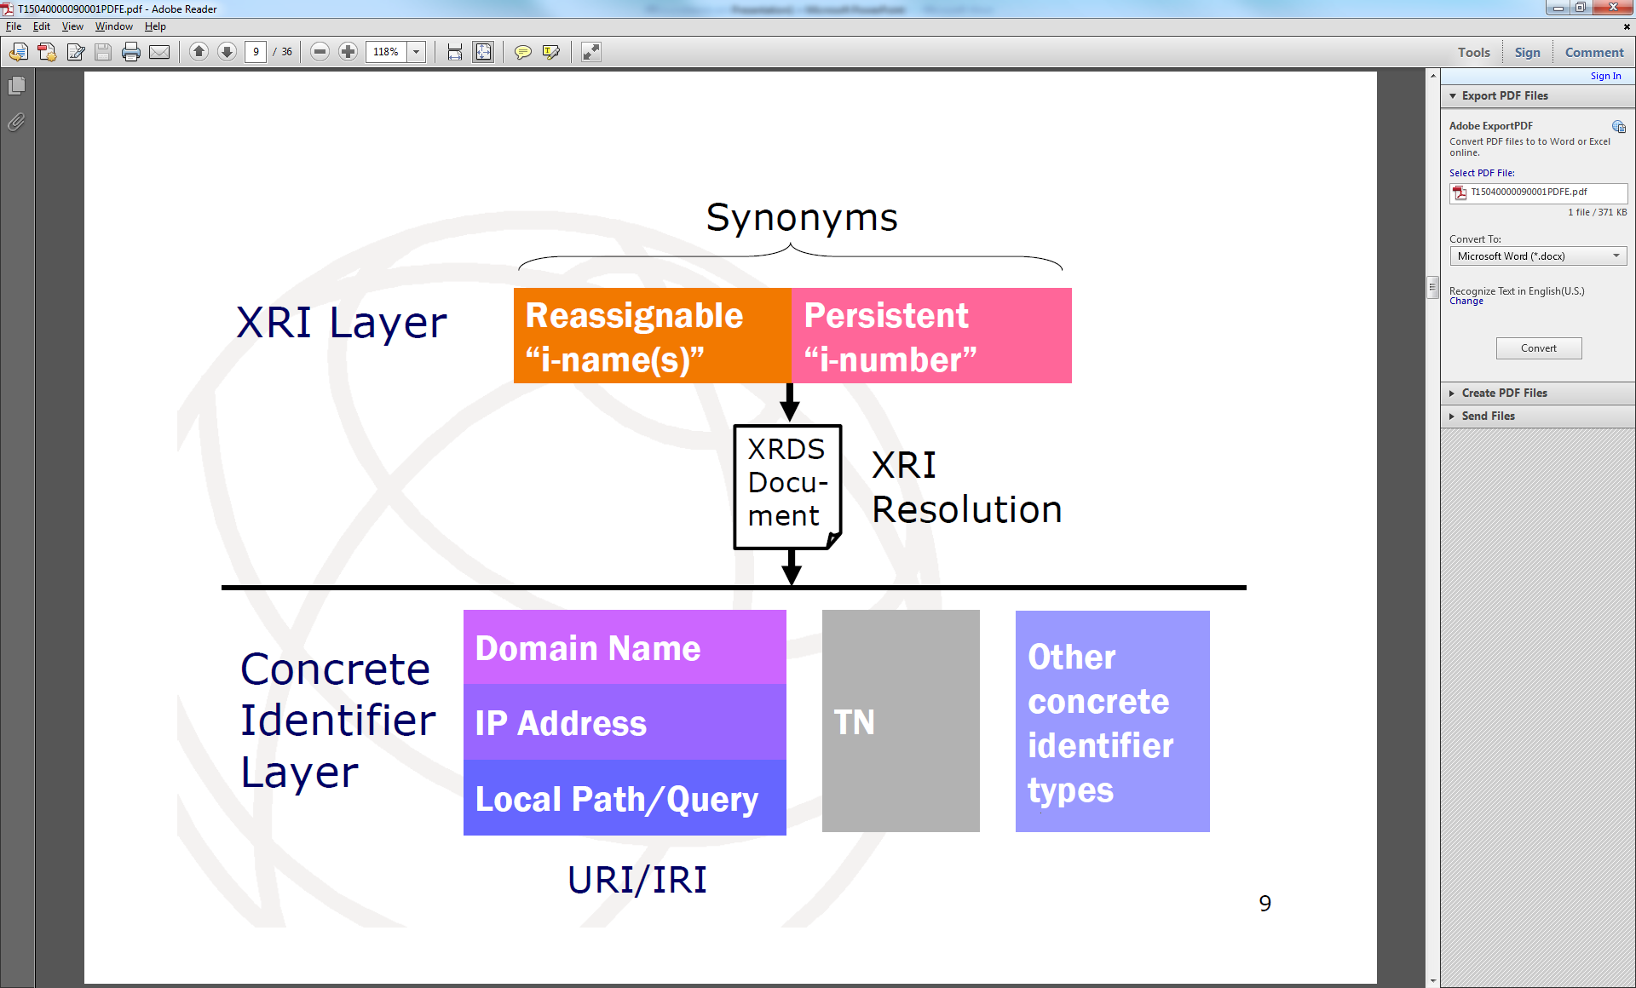

Source*

XRI resolution

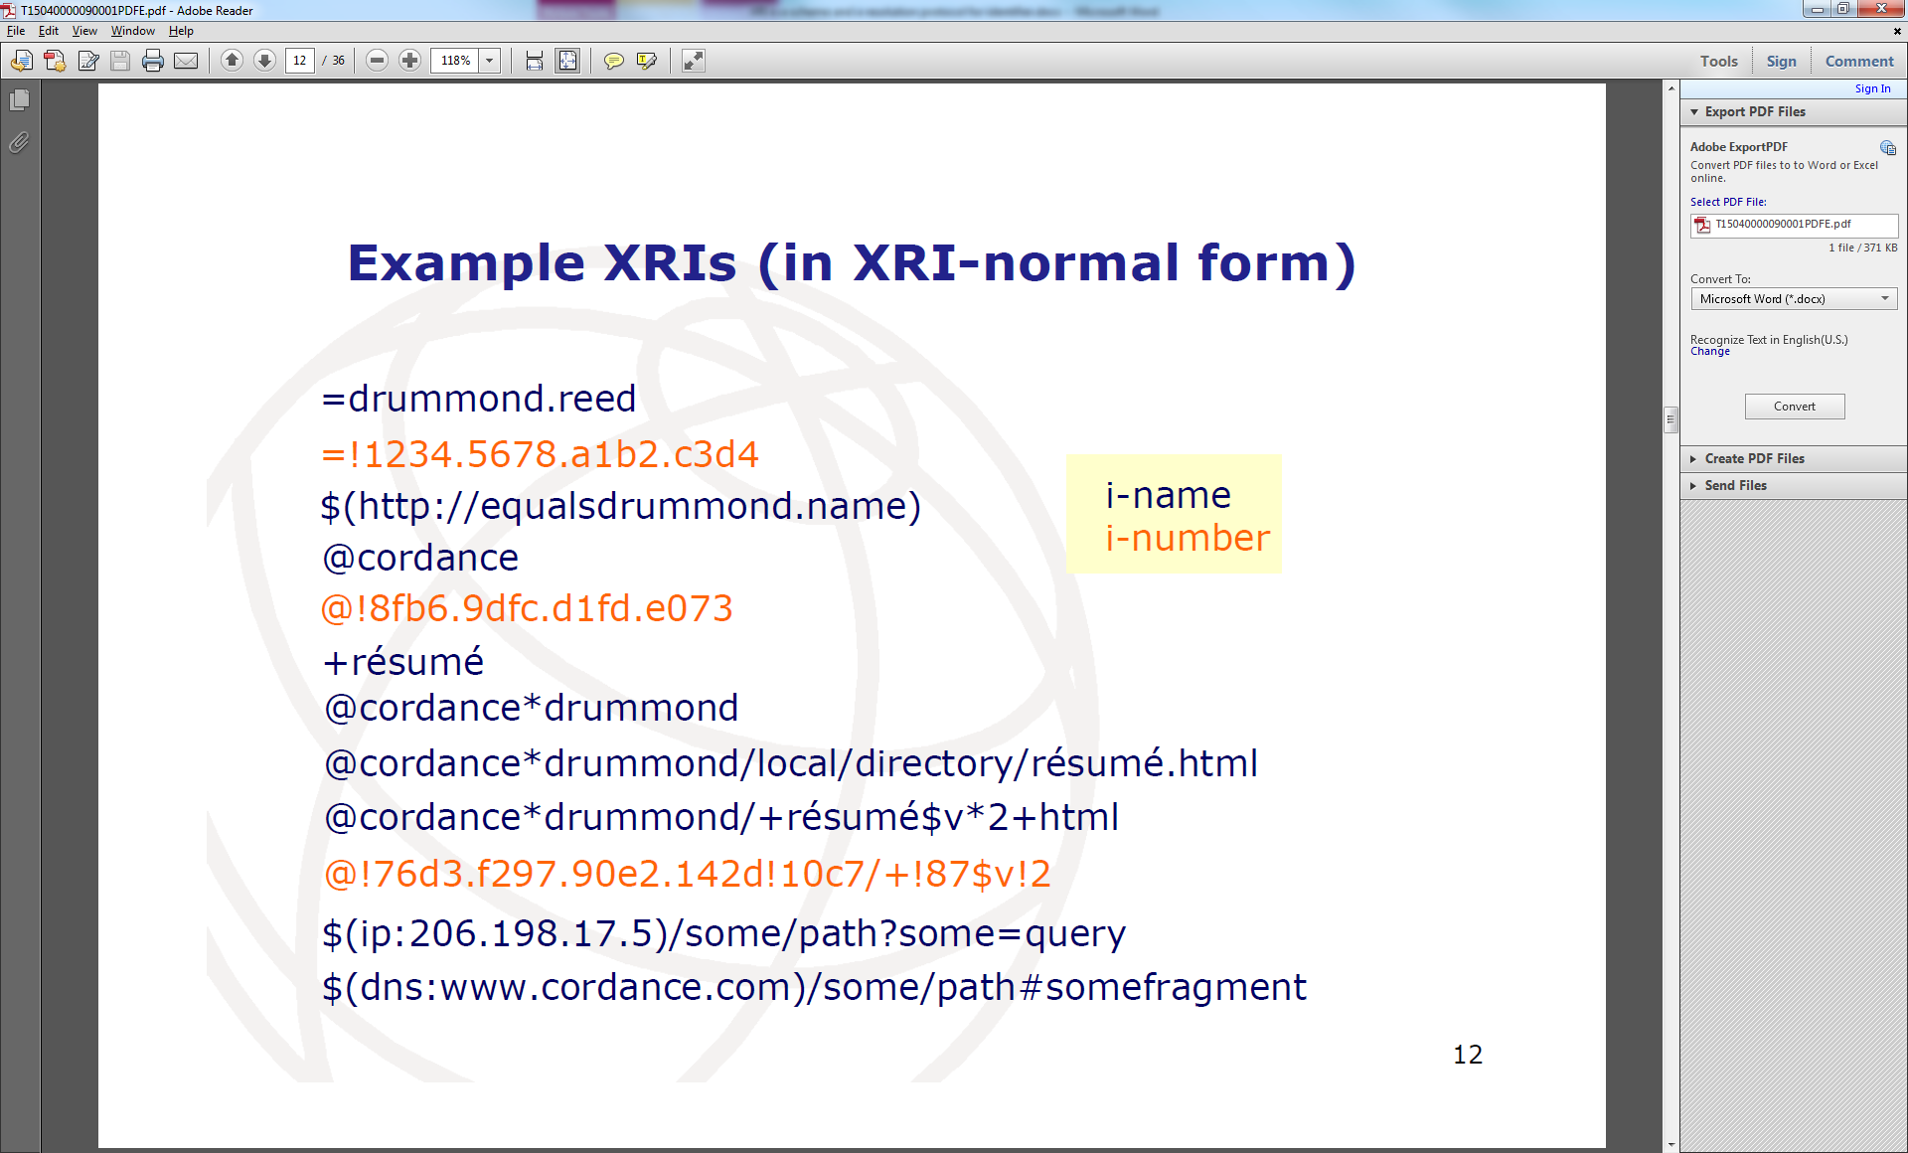

There are some features of XRI that would be great features for an IoT _ID

Advantage of features:

* The XRI syntax enables **cross-references.**

Cross-references describe identifier across different domains. That’s important feature because there are already many IoT solutions outside with own domain names and name schemes. Cross-references might be a way to integrate existing namespaces. (e.g. @city*library/(urn:isbn:23232232))

* XRI **is transport independent**. There is no specific protocol or mechanism required. Since we might have very different protocols in IoT the feature should be also applied to our approach.
* XRI is an **abstract** identifier. Abstract means the identifier might not directly point to an address. An abstract identifier is resolved to an concrete identifier and this leads to an address. This is a two/multi-step resolution. This allows e.g. for authentication during the first resolution process.
* URI/IRI compatible in fact there is a specified way to express XRIs in the form of URIs. This might be useful when it comes to compatibility with DNS and HTTP etc.

Disadvantages or why we can’t use XRI directly:

XRI was designed in a time when IoT was still not a big topic (around 2003). So many of the i-names characteristics are made for persons (=) or companies (@) and i-numbers are in fact just combinations of hexa decimal numbers, like IP-addresses. A future IoT identifier might need also a more descriptive form.

What is a community root cross-reference?

A community root cross-reference is a community root authority expressed with a cross-reference. This enables peer-to-peer identifier communities to form and evolve without registration. Using a globally unique identifier as the community root cross-reference helps ensure against name collisions (however there is no ironclad guarantee that two or more communities will not choose the same cross-reference for their root.)

Typically a community root cross-reference is identified by a URI. For example:

xri://(mailto:john.smith@example.com)*friends/name

xri://(http://example.com/john.smith)*friends/name

*Tony Rutkowski “Global Namespace Discovery using a XRI root-of-roots at assumed by ITU-T”

<https://www.itu.int/dms_pub/itu-t/oth/15/04/T15040000090001PDFE.pdf>