Privacy Enhancing Mobile Credentials
Workgroup Charter 2026
1 Executive Summary 2
2 Introduction 2
2.1 Purpose 2
2.2 Scope 3
2.3 Workstream Approach 4
2.4 Leadership 4
2.4.1 Original Proposers 4
2.5 IPR Policy 4
3 Work Plan 4
3.1 Update Version 1 Requirements 4
3.1.1 Description 4
3.1.2 Audience 5
3.1.3 Assumptions 5
3.1.4 Timeline 5
3.1.5 Output 5
3.2 Develop Version 2 Requirements 5
3.2.1 Description 5
3.2.2 Audience 5
3.2.3 Assumptions 6
3.2.4 Timeline 6
3.2.5 Output 6
4 Related Work and Liaisons 6
4.1 International Standards 6
4.2 Privacy Standards and Frameworks 6
4.3 Web Standards and Industry Specifications 6
4.4 Other Organizations 6
4.5 Kantara Initiative Work 6

1 Executive Summary
The Privacy Enhancing Mobile Credentials (PEMC) Working Group has successfully completed its initial charter period, having publishing the “Requirements for Privacy Enhancing Mobile Credentials” and completing a draft report for Conformance Testing against the requirements. This updated charter establishes the working group’s direction for 2026 and beyond, focusing on maintaining and enhancing published requirements while developing requirements for online mobile credential technologies and use cases.
Building on the foundation of conformance testing frameworks and privacy principles established in the initial phase, the working group will address evolving privacy challenges in mobile credential ecosystems, including expanded credential types, expanded participant roles in the ecosystem, cross-border considerations, and emerging privacy-enhancing technologies.

2 Introduction

2.1 Purpose
The PEMC WG creates requirements and conformance criteria to respect the privacy of individuals obtaining, holding, or using mobile credentials. The working group aims to address privacy issues that are out of scope or not addressed in existing mobile credential standards. Existing standards provide some technical and transactional assurances of user choice and data minimization at the point of presentation of the credential. Privacy, however, is necessarily the shared responsibility of all participants in an ecosystem and includes both technical and policy measures. These standards do not establish the criteria for assuring the individual that their information, including transaction records, will not be used for purposes (e.g., targeted advertising) they did not consent to. Failing to respect the interests of the mobile credential holder or meet the requirements to establish the legal authority of the verifier to collect the identity attributes could violate the privacy of the mobile credential holder.
Every stakeholder in a mobile credential ecosystem can play a role and provide assurances to respect individual privacy. The stakeholders and their relationships in this extended version of a mobile credential system include Issuers, Registrars, Holders, Verifiers, Providers, and Vendors to each of these parties. This is represented in the PEMC Trust Triangle below.
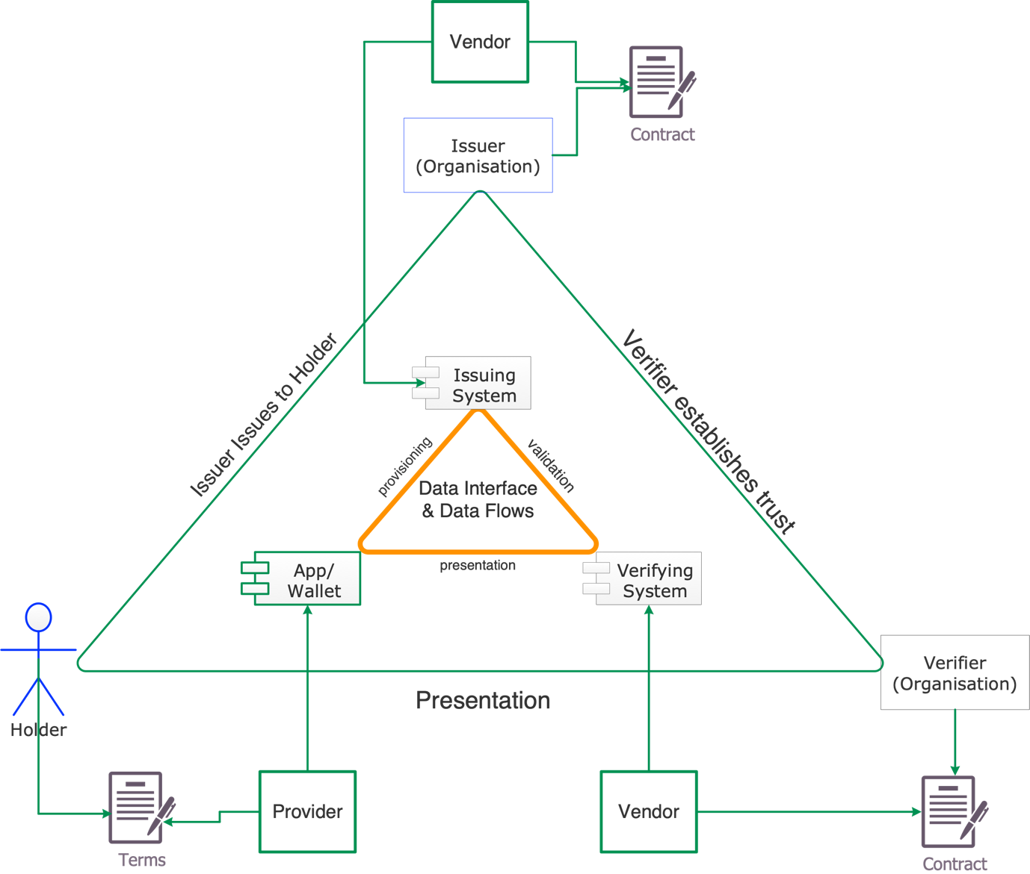
Figure 1: PEMC Extended Trust Triangle
Note: The Registrar role (for Relying Parties or Wallets) is not depicted in the diagram above. However, this role may be within scope for the analysis of requirements.

2.2 Scope
The scope of the planned work is to maintain and enhance existing requirements specifications and to produce next-generation requirements for entities that produce, hold, or consume mobile credentials and the accompanying trail of transaction data that may result. Fulfilling requirements will enable entities to provide assurances to stakeholders with respect to their privacy protection capabilities beyond the specific technical and transactional assurances provided by standards such as ISO/IEC 18013-5, ISO/IEC 18013-7, EU DI Wallet ARF, and emerging W3C standards.
In Scope:
- Credentials issued by both public sector and private sector issuers
- Mobile driving licences (mDL), verifiable credentials (VC), and other mobile credential formats categorized by NIST as Verifiable Digital Credentials (VDC)
- Privacy requirements organized by Privacy Principles as defined in ISO/IEC 29100
- Conformance testing frameworks and guidance
- Maintenance and updates to Version 1 specifications
- Development of Version 2 requirements for online use cases and expanded roles
Out of Scope:
- Collection, use, and maintenance of identifying attributes by the Issuer prior to credential issuance (these may be set by policy or regulation)
- Specific service assessment criteria, control objectives, and detailed controls (these are left to conformity assessment bodies)
- Credential security and protection mechanisms (these are addressed by existing technical standards)

2.3 Workstream Approach
The PEMC working group will establish two workstreams. The first workstream will be based on feedback from implementors using the requirements to assess their operations and providing feedback to the working group. The second workstream will develop new, or modify existing, requirements for online scenarios and use cases.

2.4 Leadership
- WG Chair: John Wunderlich
- WG Co-Chair: Christopher Williams
- WG Secretary: vacant

2.4.1 Original Proposers
Proposer | Email | Affiliation | Kantara Membership
John Wunderlich | john@wunderlich.ca | Independent | Individual
Christopher Williams | Williams.2560@gmail.com | Independent | Individual
Tom Jones | thomasclinganjones@gmail.com | Independent | Individual

2.5 IPR Policy
Kantara Initiative IPR Policy, Non-Assertion Covenant

3 Work Plan
The PEMC WG work plan for 2026 and beyond consists of two parallel tracks: maintaining and enhancing Version 1 specifications based on implementation feedback and developing Version 2 requirements to address emerging needs and expanded use cases.

3.1 Update Version 1 Requirements

3.1.1 Description
The Version 1 specifications (Verifiers, Issuers, and Providers) were published following successful member ballots. Based on implementation experience, conformance testing activities, and stakeholder feedback, updates are needed to clarify requirements, address ambiguities and newly defined ecosystem roles, and incorporate lessons learned from real-world deployments. This work includes maintaining the conformance testing framework documented in the PEMC Requirements Conformance Testing specification.
Updates will focus on:
- Clarifying existing requirements based on implementer questions
- Refining conformance testing procedures and success criteria
- Addressing gaps identified through pilot implementations
- Harmonizing requirements across Verifier, Issuer, and Provider specifications
- Incorporating errata and technical corrections

3.1.2 Audience
Organizations that have implemented or are implementing Version 1 specifications, including:
- Driving licence authorities and other credential issuers
- Verifier organizations and software/hardware providers
- Digital wallet providers and mobile credential platforms
- Conformity assessment bodies conducting PEMC conformance testing
- Standards development organizations working on mobile credential specifications

3.1.3 Assumptions
- Version 1 specifications remain the foundation for conformance
- Updates will be backward-compatible where possible
- Implementation feedback is available from pilot deployments
- The conformance testing framework provides the basis for identifying needed clarifications

3.1.4 Timeline
Duration: 12–18 months, beginning Q1 2026

3.1.5 Output
Version 1.1 specifications and conformance testing guidance.

3.2 Develop Version 2 Requirements

3.2.1 Description
Version 2 requirements will address emerging privacy challenges and expanded use cases that go beyond the initial scope of Version 1. This includes support for diverse credential types, cross-border data flows, integration with verifiable credential ecosystems, and advanced privacy-enhancing technologies. Version 2 will build upon the privacy principles framework established in Version 1 while incorporating new requirements for evolving technical and regulatory landscapes.
Key focus areas may include:
- Expanded credential types (healthcare, education, employment, travel)
- Cross-border and multi-jurisdictional privacy requirements
- Alignment with W3C Verifiable Credentials and Decentralized Identifiers
- Advanced privacy technologies (zero-knowledge proofs, selective disclosure, unlinkability)
- Ecosystem governance and trust framework requirements
- Privacy requirements for credential revocation and status checking
- Requirements for age verification and attribute-based credentials

3.2.2 Audience
Organizations developing next-generation mobile credential systems, including:
- Healthcare, education, and employment credential issuers
- Financial services and age verification providers
- Digital identity wallet providers implementing W3C standards
- Organizations operating multi-jurisdictional credential systems
- Privacy technology vendors and researchers
- Registrars and trust element distribution roles within credential ecosystems, including Wallet and Relying Party registrars
- Policy makers and regulators developing digital identity frameworks

3.2.3 Assumptions
- Version 1 specifications provide a proven foundation
- Emerging standards (W3C VC, DID, ISO 23220 series) are maturing
- Wallet credential ecosystems are evolving from pilot to operational modes
- Privacy-enhancing technologies are becoming more practical to implement
- Cross-border credential exchange is an increasing priority
- Regulatory frameworks continue to evolve globally

3.2.4 Timeline
Duration: 24 months, beginning Q2 2026

3.2.5 Output
Version 2 requirements specifications for expanded mobile credential ecosystem roles and online use cases.

4 Related Work and Liaisons
The PEMC WG maintains awareness of and coordination with related work in other working groups and standards organizations. Key relationships include:

4.1 International Standards
- ISO/IEC JTC 1/SC 17: Cards and security devices for personal identification
- ISO/IEC JTC 1/SC 27: Information security, cybersecurity and privacy protection
- ISO/IEC 18013-5: Personal identification — Mobile driving licence (mDL)
- ISO/IEC 18013-7: Mobile driving licence (mDL) add-on functions
- ISO/IEC 23220 series: Building blocks for identity management via mobile devices
- ISO/IEC 29100: Privacy framework

4.2 Privacy Standards and Frameworks
- ISO/IEC 27701: Privacy information management
- ISO/IEC 29134: Guidelines for privacy impact assessment
- ISO/IEC TR 27550: Privacy engineering for system life cycle processes
- IEEE P7002: Data Privacy Process
- NIST Privacy Framework
- NIST SP 800-53: Security and Privacy Controls

4.3 Web Standards and Industry Specifications
- W3C Verifiable Credentials Data Model
- W3C Decentralized Identifiers (DIDs)
- W3C Verifiable Credentials Working Group
- FIDO Alliance Digital Credentials Protocol
- OpenID Foundation Verifiable Credential Issuance and Presentation

4.4 Other Organizations
- SIDI-Hub Trust Framework and Trust Management Guidance

4.5 Kantara Initiative Work
- Kantara PImDL Report: Privacy and Identity Protection in mobile Driving Licence Ecosystems
- Other Kantara Initiative working groups addressing digital identity and privacy
- Kantara Conformity Assessment Bodies and Trust Framework programs
- Kantara Advanced Notice and Consent Receipts Working Group
- Kantara Risk Universe Discussion Group

