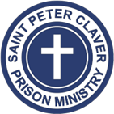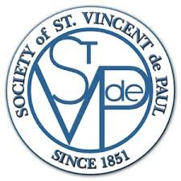

October 2025 Progress Update: Training for Transformation
St. Peter Claver Prison Ministry & Promising People Partnership
Since June 2024, our collaboration with Promising People LLC has turned vision into action. Together, we’ve created a hands-on, high-tech training hub at our shared facility in Casselberry, Florida, empowering formerly incarcerated individuals to gain the skills—and confidence—needed for lasting change.
Through Virtual Reality (VR) vocational training, participants experience immersive lessons in trades like electrical, construction, and safety certifications, preparing them for real-world employment. The partnership’s connection with Tri-City Electrical, Florida’s largest electrical contractor, ensures a direct pathway from training to hiring—a powerful step toward stability and self-sufficiency.
In just the first phase of this initiative:
• Dozens of Returning Citizens have completed modules in the Electrical Helper Program, OSHA safety, and workplace readiness.
• Several graduates have already secured employment earning sustainable wages.
• Each participant leaves with a clear plan for housing, employment, and mentorship through SPCPM’s wrap-around support network.
Our joint mission remains strong: to break the cycles of recidivism and homelessness by replacing despair with opportunity. Every headset, every class, and every job placement represents more than progress—it’s a second chance realized.
Together, we are building futures grounded in faith, dignity, and hope—one life at a time.
Carlos Benitez
Executive Director, St. Peter Claver Prison Ministry
Florida Site Coordinator, SVDP Immersion Reentry Program
Community Partner, Promising People Workforce Development
📍 6585 S US Hwy 17-92, Fern Park, FL (PO Box 201)
🌐 www.spcpmorlando.org | www.promisingpeople.com

