Subject Delegation of Authority
Version: 1.0 draft 11
Document Date: 2025-12-05
Editors: Tom Jones
Contributors: Justin Byrd, Salvatore D’Agostino, Jorge Flores, Jim Kragh, Noreen Whysel, Tom Jones
Produced by: <"Group Full Name" property:"Manager">
Status:
This document is a Group-Editors' Draft Report produced by the <"Group Full Name" property:"Manager">Error! AutoText entry not defined. See the Kantara Initiative Operating Procedures {op href} for more information.
Abstract:
The Subject Delegation of Authority (SDA) is designed for inclusion in a presentation of personal data prepared by a Credential Holder on behalf of the Subject of a credential. The SDA is a statement that the Holder of the credential has been given the Authority as a token that enables the creation of the presentation of the Credentials, which have been issued to the Subject. The SDA is a machine-readable token attested by an authority (or collection of authorities) known to the Verifier. The holder will include this token in any presentation where it is not the subject.
The purpose of this SDA is to expand the benefits of Digital Public Infrastructure (DPI) to everyone, regardless of their ability or access to a mobile digital device, like a smartphone. The intended audience for this report is technical developers and architects of standards and implementations.
IPR Option:
--Error! AutoText entry not defined.
Suggested Citation:
<"Document Title" property:"Title"> M.n draft x. Kantara Initiative <"Group Full Name" property:"Manager">. yyyy-mm-dd. Kantara Initiative Document OR Recommendation OR Report OR Technical Specification Recommendation. HREF

NOTICE


-

Error! AutoText entry not defined.Copyright: The content of this document is copyright of Kantara Initiative, Inc.
© 2025 Kantara Initiative, Inc.
Contents
1. Introduction 5
1.1. Problems 5
2. Goals 7
3. Proposed solution 9
1.3. What is Delegated 9
1.4. Example Use Cases 9

Introduction

Problems
Problems with inclusion have already arisen in apps designed for refugees that were not accessible in the Subject’s language. This is a current problem that will only get worse as more enterprises issue credentials in digital format. A delegate statement can be included in a presentation from a subject credential that has been provided to any person who is entitled to access a service or other resource, for example:
- States reduce the availability of local in-person support personnel and instead rely on centralized online support.
- Not able to communicate in the local or preferred language, where even a grandchild could function as the delegate holder (HHS 2023).
- Aware but not capable of handling the requirements of digital devices.
- Unable to give informed consent on their own behalf.
- In an emergency where the subject has no internet access.
For more information about the use of credentials on mobile devices, see Kantara 2025 - Requirements for Privacy Enhancing Mobile Credentials 1.0. Kantara Initiative Recommendation. (link below)

Taxonomy
These are the terms that are used in the attached diagram and throughout this document.
Subject = any entity that needs assistance to participate in a Digital Public Infrastructure.
Human = the source of all agency
Permission = not necessarily legal delegated authority, but accepted by the subject.
Authority = authorization or permission to perform some task or series of tasks on behalf of the Subject. The scope of the Authority is determined by the policy contained solely in the SDA.
Intelligent Agent = any programmatic entity supporting the subject that may or may not have authority, for example, a programmatic interpreter.
Entity = any object with the appropriate verifiable identifier, such as agents, organizations and people.
Delegate = an Entity that can act on behalf of the subject with whatever authority is contained within the scope of the SDA. (Either human or programmatic)
Delegation = the process of creating authority to perform some specified set of actions on behalf of a subject
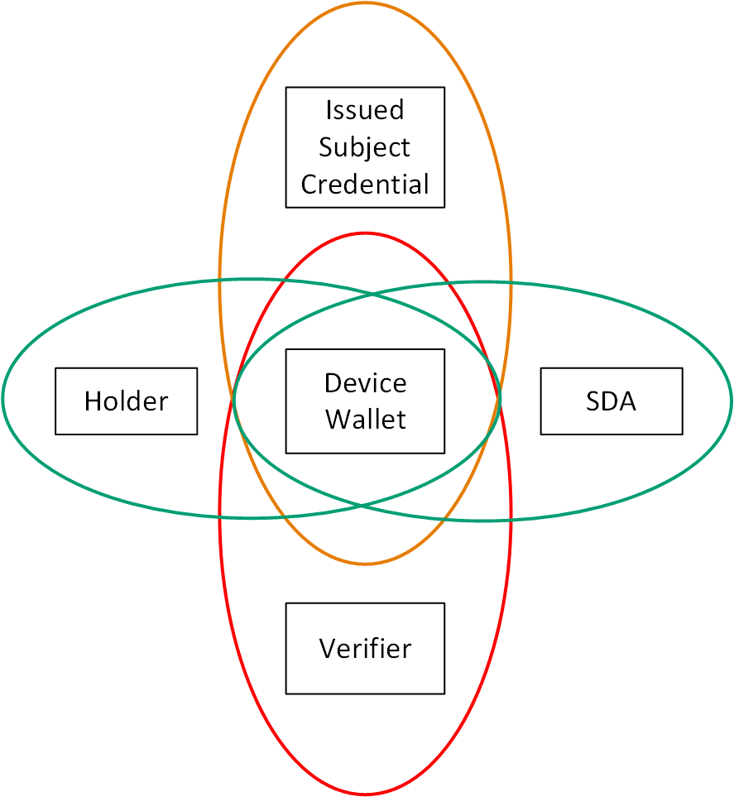
Autonomous Agent = a programmatic entity that is not a delegate and is not controlled by an SDA.
Interpreter = an entity that must have subject permission, but does not require legal authority to explain the contents of a request to the subject. (Can be an autonomous agent)
Presentation = a collection of data from credentials about the Subject created under the control of the Holder.
Holder = a person with a digital device and the authority to acquire credentials about the Subject and act on behalf of the Subject to create Presentations to share.
Wallet = a user agent that can hold secrets on behalf of the Holder. The wallet has the responsibility to evaluate any request for information from a Verifier to be sure it is authorized.
Subject Delegation of Authority (SDA) = a Subject Credential issued to the Holder or other Agent on the device.
Issued Subject Credential = a signed collection of Subject Identifiers and Attributes that might be required by the Verifier.
Verifier = an entity that needs proof that the subject has provided consent and verified information needed to access a resource controlled by the Verifier operating as or on behalf of a Relying Party or Data Controller.

Goals
This is the delegation subset of the identifier ecosystem’s goals stated elsewhere. This specifically addresses the needs of a human Holder or automation in a wallet to control the information about a human subject.
- Credentials shall be reasonably available for all subjects that are eligible for digital credentials needed for their day-to-day transactions, with no exceptions.
- The introduction of the SDA is specifically designed to increase accessibility to digitally enabled resources and must not add new burdens.
- Reduce any additional burden created by the introduction of digital technologies.
- The acquisition of digital credentials must not be used to target any individual for state actions that are unrelated to the purpose of those digital credentials. For example, the enrollment of an eligible child for school attendance should not be used to locate and expel or incarcerate a parent of the child.
- Where the subject needs a delegate to get necessary access, the wallet and verifier will accommodate multiple subjects or holders for a Holder’s device.
- Institutional settings will allow the current shift worker, during their shift time, the ability to act as the authorized Holder of the device with the subject’s credentials.
- Show use cases where a delegate is needed to release a subject’s data where the subject is not able to make the response on their own.
- Works for first responders like medical technicians or disaster recovery operations, where internet connectivity is not available.
- A Query can be generated by a simple device in a small shop with all of the information required by the shop to complete the transaction. This should include payment as well as age verification, for example. An internet connection is not required to complete the transaction for any normal use case.
- This query will help small verifiers to show compliance with privacy standards like the Kantara Privacy Enhanced Mobile Credentials (PEMC 2024).
- Delegation of authority continues to function when the subject becomes incapacitated, disfigured, or has died. Clearly, this goal is modified if proof of presence of the subject is required.
- The only use cases addressed here are where a Verifier has initiated a query to a device in the Holder’s possession. Either the device or a wallet app on the device will be able to accept the query and craft a response that includes an SDA.
- Only quantum-resistant security protocols will be supported.

Proposed solution

What is Delegated
As the use cases below describe, there is a wide range of functions that may need to be delegated so that any party relying on the attributes contained in a subject credential has access to it. The following are some of the functions to consider in the creation of the scope of the delegation:
- Whole Life Delegation - an irrevocable assignment of responsibility which applies to a newborn child until they acquire authority to act on their own, as well as a person who has lost the ability to make decisions.
- Short-term Delegation of Personal Responsibility - a revocable assignment of responsibility for health decisions.
- End-of-life Decision - a revocable assignment of health care decisions when a health care expert determines that my current state of health enables their agency.
- Mental Health Condition - usually in the hands of a probate judge who determines that responsibility is given to a health care agency until the condition is determined to have been resolved. Typically involves institutionalization.
- Monetary Agency - when a probate judge determines that a human is not capable of preserving their own financial independence.
- Translation - when a person is fully in control of their own decision but needs help in converting from one language to another. This could involve a young grandchild helping a grandparent at a border crossing or hospital.

Example Use Cases
Use cases show the problems and proposed solutions for the DPI, especially when an agent, either human or digital, is required. The question is where and how an SDA can be created, such that the SDA can reasonably be generated.

Authority request after the Agent describes the Action
A subject seeks to purchase a lamp given a set of possible choices. At first, the subject gives the agent a series of prompts to get down to one that fits the subject’s needs. Once that is complete, the subject gives the best solution the authority to make a purchase and pay the bill.
The SDA is generated in the subject's wallet with a transaction-specific identifier, allowing an agent to complete the purchase. The subject's key and agent identifier are bound to a single scope and action: “complete purchase and make payment.” The agent can now present the SDA to a vendor and make the purchase on behalf of the delegate.

Dependent Child of a Farm Worker
Roberto, a Spanish-speaking farmworker, is experiencing intermittent chest pain during the peak of apple harvest season. Due to language barriers and limited digital literacy, he cannot navigate the healthcare system or online patient portals himself. As a result, he asks his daughter, Alicia, to handle the process of scheduling a medical consultation on his behalf.
While Alicia is digitally capable, healthcare systems typically require the patient to directly interact with apps or portals. Without proper authorization mechanisms, Alicia risks being locked out or forced to use informal, potentially insecure workarounds like shared passwords or impersonation.
Roberto and Alicia use Roberto’s device to set up a short-duration SDA that lets Alicia handle his basic health-access tasks. Roberto signs in once with a PIN or biometric, picks Alicia as the delegate, and agrees to the limited purpose of scheduling an appointment and sharing non-diagnostic information. The wallet signs the SDA and passes it to Alicia’s device. When the clinic asks for authorization, Alicia’s wallet can provide Roberto’s credentials along with the SDA to show she is allowed to act on his behalf.

Application for Asylum at the US border
Any applicant must acquire a smartphone that supports the CBP ONE app. If the app does not support the language of the subject, there must be some other mechanism for the subject to enter the information in the smartphone to schedule the appointment for an asylum application. It may be necessary for the subject to get an acceptable interpreter to help with the application above and beyond if an intelligent agent is available directly from the app.

Human in a Care Facility
The preliminary use case is for a device (like a smartphone) that can be at a patient’s bedside and accessed by a care-worker on shift at the time. This will be used as a medical care device, potentially replacing the sheet now pinned to the foot of the bed. It can also be attached to a wheelchair for use when the patient is mobile.

Holder has an older phone
Most security and AI updates require that the smartphone is current and will end services on older phones. The telcos are asking for older phones to be returned. Can we approach the telcos and phone manufacturers for help with an effort to broaden availability to the underserved?

Transit services are moving to Smartphones
The magstripe or chip cards that the underserved depend upon are being deprecated. Many of the current users of the MetroCard do not have a smartphone that is new enough to allow download of the current app from the Metro service.

Human has a State-Issued Digital Identifier
Eventually, most governments will have the ability to issue their Identifiers in digital form that needs some sort of hardware protection of keying material if they are to be loadable on devices carried by Humans. For example, when a family unit, including young children, can only afford a single mobile smartphone, it must be possible for that device to hold all of the individuals’ identifiers within that one device. As currently designed, smartphones will have biometric proofing for the device holder, so a delegation of the other members' credentials to that Holder for presentation is recommended.
https://digitalgovernmenthub.org/publications/digital-doorways-to-public-benefits-user-experiences-with-digital-identity/

Human uses an Intelligent Agent
Where today an older patient might rely on an adult child to be their (delegate) agent, that function could equally be handled by an Intelligent Agent. For any Intelligent agent to act on behalf of a Human. For example, create a service principal or application identity in a smartphone where the subject may or may not be the device Holder. Acquire a unique, persistent identifier such as the instance ID proposed in eIDAS. As a part of that initialization, get a hardware-protected key for the Agent and the Human. Get help creating a policy for that AI Agent from a native speaker.
The Agent that is assigned to the patient must have a unique instance identifier for audit and other purposes. There needs to be an SDA tied back to the patient issued by a responsible party.

Access to Social Services like Medicare and SNAP
The information needed to give good health care often includes highly personal information. In this case, the verifier must be known to be capable of protecting the subject’s very personal information from disclosure.
Part of the problem is to find the right source of information to solve the problem for a person who needs assistance to find a solution when a government office is not locally available. Too many options - where is assistance when it is needed?

Emergency Care
In the case of a non-responsive emergency patient or any subject that cannot be trusted to reliably report on their own condition, the agent may contain information about medical conditions, internal devices, allergies, medications, or a healthcare directive or living will. The patient will have allowed their phone to communicate information, but only to a caregiver who has authorization to access the information. In this case, the request from the caregiver must include the authority delegated to them as authorized at that place and time to make the request. The holder/patient will have already authorized their digital device to accept and respond to such a request.

Prison Ministry Project
For millions of individuals exiting incarceration, the path to a stable life is systemically blocked by a lack of identity credentials. Lacking the standard documentation and verifiable history required by modern digital systems, they are rendered effectively invisible, locked out of opportunities for employment, housing, and essential services. The Promising Initiative (PI) proposes a definitive solution to this cycle of marginalization by integrating its state-of-the-art virtual reality skills training such as a Universal Unique Identifier (UUID) system, a secure, human-centric digital identity framework. This sociotechnical model provides not just in-demand skills, but the trusted, portable credentials necessary to prove them.

Statement of Provenance of Authority
Verifiers are permitted to ask only for information that they are authorized to collect. One example is a border agent, or building access guard, who has the authority to make a request for any information that is required to grant access, for example, to a nuclear power plant. The authorization information needs to pass from the verifier to the Holder’s wallet before the information is released by the wallet.

Intelligent Agent for Human (Greenwood 2024)
Wallets run biometric or other tests to ensure that the Holder of the credential is present at the device for the transaction to proceed. In the future, we can expect the Wallet to serve as a user agent and initiate transactions on a scheduled basis, just as they do today for turning lights on and off in the home. In this case, the Wallet must authenticate itself and provide proof that it is a delegate for the Subject of the Credential. For example, a smart watch can determine and report medical emergencies based on prior grants of subject consent.

Accessibility of Solutions with the SDA
Implementing a distributed governance model based on a Subject Delegation of Authority (SDA) framework can enhance the inclusivity of digital public infrastructure (DPI) by delegating authority across macro, meso, and micro levels. This approach leverages principles of componentization, ownership, governance, accountability, ecosystem value, and evolution to create a more user-centric, responsive, and accountable digital ecosystem, mandating features like user-centered design, inclusive policies, diverse service channels, and data protection. More details on this framework are available in Key Principles for Digital Public Infrastructure by Carl Ward https://www.linkedin.com/pulse/key-principles-digital-public-infrastructure-carl-ward-viysc/

Disabled Company Director
- On 2025-11-18, in the UK, it becomes mandatory to verify your identity as a company director or a person with significant control. In this case the DPI requires a human to access and modify a database or existing company registrations will be removed.
- All of the methods to verify online require that you use a mobile phone or other mobile device. There is no option to use an alternative email address to verify the account, for example. Using somebody else's mobile phone to verify one's identity does not seem particularly safe without delegated credentials. A disabled person may not be able to use a mobile phone or other mobile device, and have not been provided a photo ID which is theoretically optional. In addition, there is no ability to create an online account because the only way to do so is to provide a mobile phone number or use a mobile phone app. If housebound there is no ability to visit an agent. There appears to be no provision for an agent who can facilitate the verification of an identity without visiting a government site in person.
- The standard reply email just reiterates how to verify human identification. None of these emails recognizes the need for a mobile device just to create an account, and a photo ID requirement. The core issue is that the DPI does not provide the means to even maintain existing rights under the law to have a personal corporate account.
- What Comes Next
The introduction of the Subject Delegation of Authority (SDA) enables digital ecosystems to support subjects who cannot directly operate a device or respond to a verifier’s query. The next step is to ensure that SDA can be consistently created, recognized, and verified across all implementations of digital credentials.
- What will a successful solution look like?
A successful solution is one where a subject who cannot use a device or respond to a verifier on their own is still able to access the services they are entitled to. In this model, a holder or designated delegate can present the subject’s credentials, and the verifier can see from the SDA that this is allowed without needing extra explanations or exceptions. The overall process should be simple enough that subjects and delegates can understand what is happening, but still reliable and secure from the verifier’s point of view. When this is in place, SDA becomes a routine part of the credential flow rather than something that requires special handling or manual workarounds.

Call to action
Implementers of wallets, verifiers, digital agents and credential issuers should begin adding support for recognizing and processing an SDA in all digital transactions. There is work needed to get consistent data structures and policy expressions in place so that delegation behaves the same way across different systems. Standards developers should also look at where delegation is already happening informally today, like shared passwords or asking staff to “log in for someone,” and replace those practices with a clear and auditable SDA. Organizations that work directly with underserved communities, care facilities, social services, or high-risk situations are encouraged to test these ideas early and provide feedback on what actually works for the people they support.

How can the underserved community be fully accommodated?
SDA makes it possible for people who do not have a suitable device, who struggle with language or digital skills, or who cannot meet biometric or authentication requirements, to still participate in digital public infrastructure (DPI). Families who share a single device can use it for multiple subjects. People who rely on caregivers or case workers can have those helpers act on their behalf without unsafe workarounds. Service providers can accept delegated presentations in a way that protects the subject’s privacy and avoids forcing them to travel, fill out long forms, or hand over their device. In short, SDA helps close gaps that digital systems often widen.

References
Dazza Greenwood Nov 22, 2024 - When AI Agents Conduct Transactions https://www.dazzagreenwood.com/p/when-ai-agents-conduct-transactions
George Fletcher 2025 - Delegation in OIDF https://www.linkedin.com/pulse/components-on-behalf-of-delegation-pattern-george-fletcher-hzhbe
HHS 2023 - US Health and Human Services - Must a covered health care provider obtain an individual’s authorization to use or disclose protected health information to an interpreter? https://www.hhs.gov/hipaa/for-professionals/faq/760/must-a-covered-provider-obtain-individual-authorization-to-disclose-to-an-interpreter/index.html
Kantara 2025 - Requirements for Privacy Enhancing Mobile Credentials 1.0. Kantara Initiative Recommendation.
https://kantarainitiative.org/download/requirements-for-privacy-enhancing-mobile-credentialskantara-initiative-recommendation.

